CreditCards Filter & Sort
Testing Script/Discussion Guide
Revised:
01/19/2013

Statement of Purpose

This study is comprised of the following sections with their respective purposes:

- Demographic Survey
  - To gather basic demographic data to ensure that participants meet the screening criteria.
  - To provide data points for further segmentation and analysis of participants’ data.
- Card Sorting – Credit Card Names
  - Using Non-Bank Identifiable Genericized Names, Particpants will sort card names into 5 unnamed categories based on their perception of how the cards group together. Participants will then name the categories and provide a brief description of that category.
  - This task will provide data on the effect of credit cards names on their perceptual grouping in the particpants’ minds.
- Card Sorting – Credit Card Descriptions
  - Using Non-Bank Identifiable Genericized Descriptions, Participants will sort card descriptions based on their summaries and value propositions into 5 unnamed categories based on their perception of how the cards group together. Participants will then name the categories and provide a brief description of that category.
  - This task will provide data on how the value propositions effect the participats’ perceptual grouping.
- General Questionare
  - To assertain participants’ feelings of necessity with respect to such items as using search fields, interactive tools and filters while shopping for a credit card.

Methodological Summary

This study is a remote usability study and does NOT include any in-person lab sessions:
- 70 remote unmoderated usability testing sessions will be conducted for CitiCards redesign Filter and Sort task. Participants from different locations in the US (Non Citi Customers who comply with the screener requirements) will join from their home at their convenience.
- 70 Participants have been determined to be the optimal number to return results with a 99.5% Confidence Interval, per research via Tullis and Wood, UPA, 2004 (http://home.comcast.net/~tomtullis/publications/UPA2004CardSorting.pdf)

Sessions will run as follows:
- Participants are recruited and provided a unique UserZoom URL to join the test.
- Participants join remotely
- Participants read the instructions in the UZ tool and begin the test.
- Data is collected by the UZ tool for examination and analysis by Citi.

Pretest Statement

The following statement is presented to each participant before the start of each session:
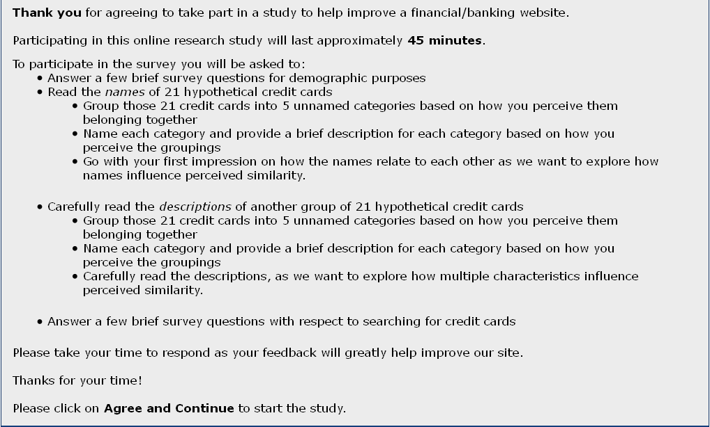

Instructions

The following screen is presented to each participant before the start of each session.
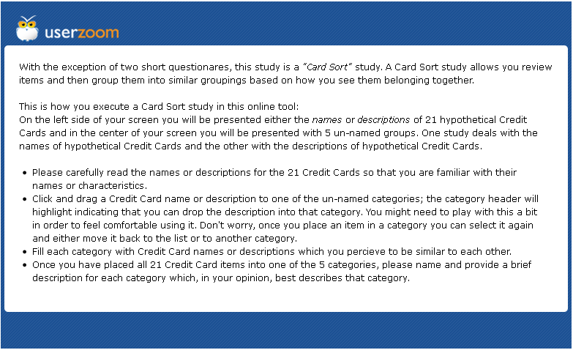

Initial Questionaire

Participants will be asked the following questions as presented below:




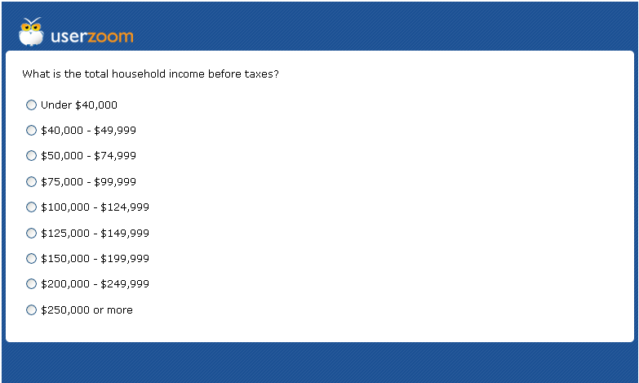



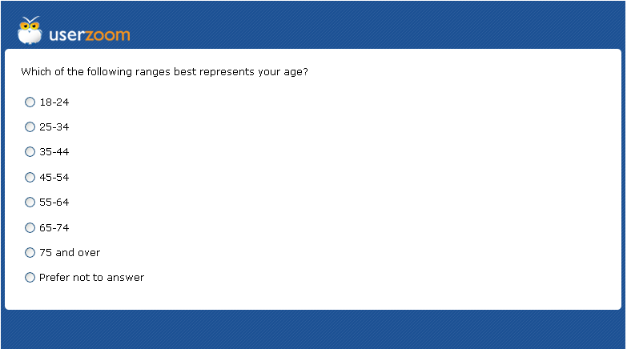

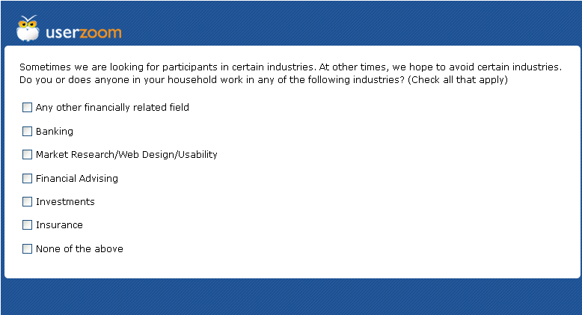
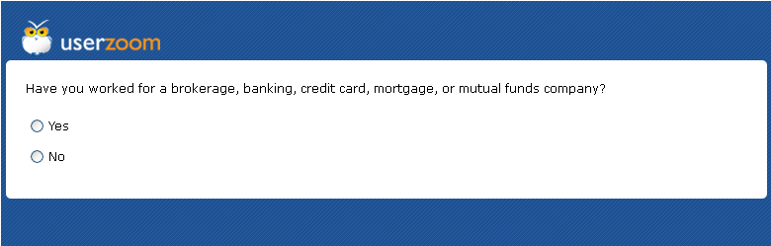
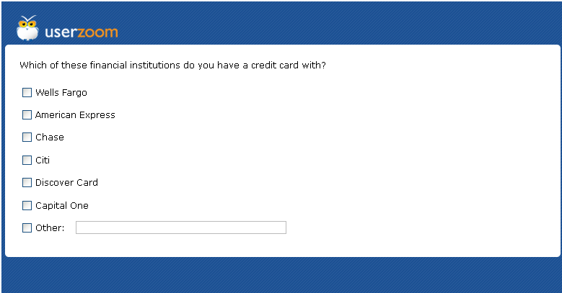

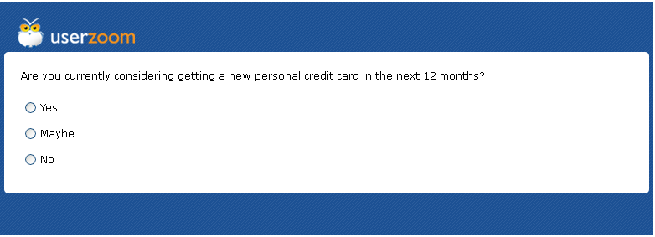

Task 1 – Card Sorting – Credit Card Names

Participants will be given the following task specific instructions as presented below:

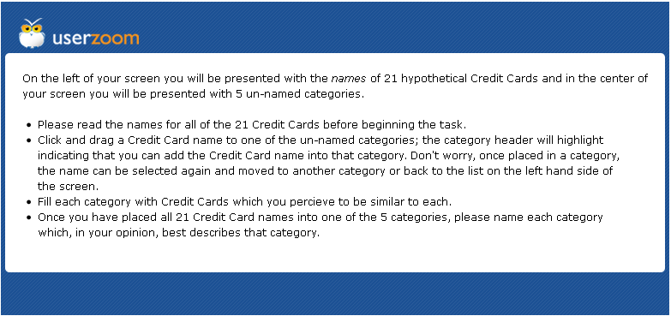
Credit Card Names used in this part of the study are Non-Bank Identifiable Names that are Genericized versions of 21 Citibank Credit Cards. They are as follows:
- ABC Bank Simple Visa Card
- ABC Bank XYZ Airline Visa Autograph Card
- ABC Bank Points Favorite Card
- ABC Bank XYZ PayBack Visa Card
- ABC Bank Emerald Favorite MasterCard
- ABC Bank Points First Card
- ABC Bank Points Card
- ABC Bank Business / XYZ Airline Global MasterCard
- ABC Bank Hotel Visa Autograph Card
- ABC Bank Hotel Reserve Visa Card
- ABC Bank XYZ Airline Global MasterCard
- ABC Bank Airline American Express Card
- ABC Bank Corporate Head /Airline Global Executive MasterCard
- The Newest ABC Bank Status MasterCard
- ABC Bank Metallic / Airline Visa Autograph Card
- ABC Bank Telephone Company Savings & Rewards MasterCard
- ABC Bank Telephone Company Savings Metallic MasterCard.
- ABC Bank Business Points Card
- ABC Bank UP Visa Card for College Students
- ABC Bank Interest Metallic Favorite Visa Card for College Students
- ABC Bank Telephone Company Business Points Visa Card

The following is a screen shot of how the user will see the opening screen.
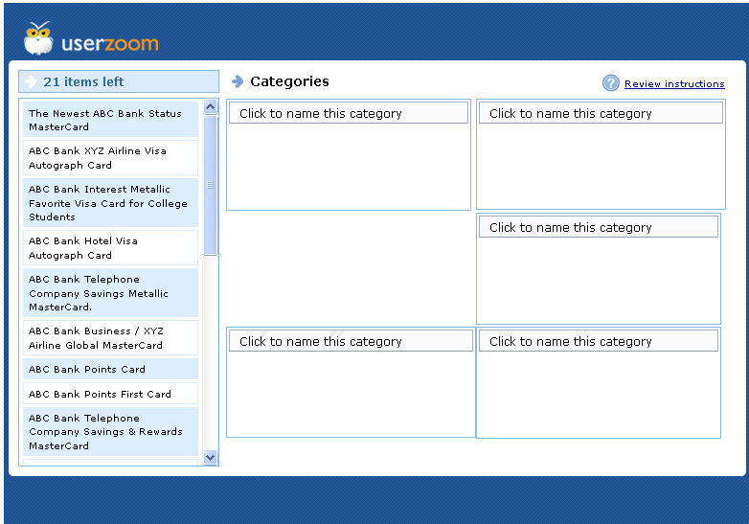
The following is a screen shot of the user being asked to provide a name and description for the categories they populated with card names.
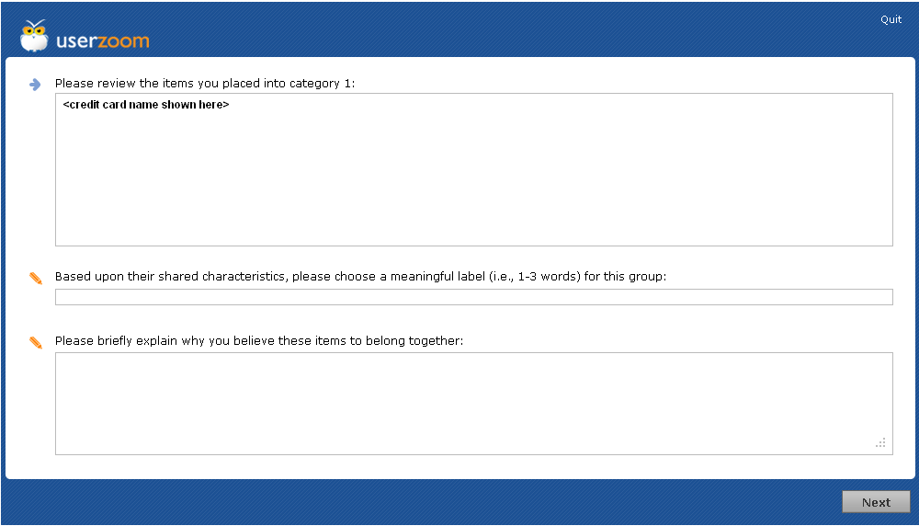

Task 2 – Card Sorting – Credit Card Descriptions

Participants will be given the following task specific instructions as presented below:

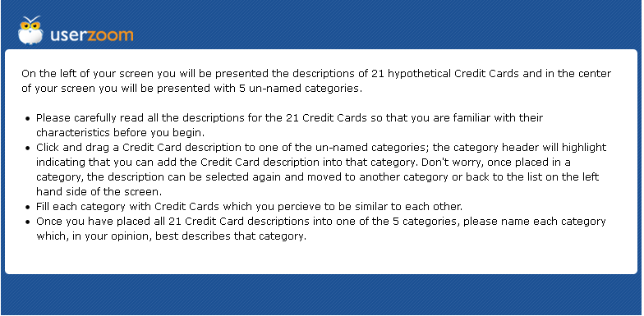
Credit Card Descriptions used in this part of the study are Non-Bank Identifiable descriptions that are Genericized versions of 21 Citibank Credit Cards; they were created to retain a generic version of the current value propositions without using Citi terminology, names, or indicating any affiliation with Citi. They are as follows:
- Card #1; 0% Intro APR on purchases and balance transfers for 18 months. No late fees nor penalty rate; No Annual Fee;
- Card #2; 30,000 Airline bonus miles. Double miles on eligible flight purchases. 10% of your redeemed Airline miles back; $95.00 Annual Fee after 12 months after 1st year, 15.24% Variable APR;
- Card #3; 10,000 bonus points; No Annual Fee; 0% Intro APR on purchases and balance transfers for 12 months; Card #4; $100 cash back. 1% cash back on purchases. 5% cash back on specific merchants; No Annual Fee; 0% Intro APR on purchases and balance transfers for 12 months; Card #5; Enjoy 0% Intro APR on purchases and balance transfers for 18 months. 24/7 concierge service. Special ticket presales, preferred seating, VIP packages; No Annual FeeCard #6; 25,000 bonus points. Annual companion ticket and 15% discount; $125.00 Annual Fee after 12 months; 13.99%-22.99% APR based on creditworthiness;
- Card #7; 0% Intro APR on purchases and balance transfers for 15 months. 1 Point per dollar spent; No Annual Fee; 0% Intro APR on purchases for 15 months; Card #8; 30,000 airline bonus miles. Double Miles on XYZ Airlines purchases; $95.00 Annual Fee after 12 months; 15.24% Variable APR; Card #9; 40,000 Hotel Bonus Points. 6 Hotel Bonus Points per dollar spent on hotel stays. Preferred Hotel status; No Annual Fee; 14.24% APR (variable for Visa Signature or 16.24% variable for Visa Gold);
- Card #10; 2 weekend night certificates at select hotels.10 Hotel Points per $1 spent on hotel stays. 5 Hotel Points per $1 on airline and car rental purchases. 3 Hotel Bonus Points per $1 on all other purchases; $95.00 Annual Fee; 15.24% Variable APR; Card #11; 30,000 XYZ Airlines bonus miles. $100 XYZ Airlines Flight Discount. 2x miles on eligible XYZ Airlines purchases. 10% of your redeemed miles back; $95.00 Annual Fee after 12 months); 15.24% Variable APR;
- Card #12; Earn 25,000 XYZ Airlines bonus miles after $750 in purchases. 1 Airline mile for every $1 you spend. Reduced Mileage Awards; $50.00 Annual Fee after 12 months); 15.24% Variable APR;
- Card #13; 10,000 Elite Qualifying Miles from XYZ Airlines. 25,000 XYZ Airlines bonus miles after $1,000 spent. 1 mile for every $1 spent; $450.00 Annual Fee; 15.24% Variable APR; Card #14; 30,000 bonus Points. Up to $200 in statement credits for airline fees. Hotel Gold status, yearly companion ticket. 2 points for every $1 spent at restaurants; $400.00 Annual Fee; 15.24% Variable APR;
- Card #15; 25,000 XYZ Airlines bonus miles after $750 spent. 1 mile for every $1 you spent; $50.00 Annual Fee after 12 months); 15.24% Variable APR; Card #16; 10,000 bonus Points after $500 spent. Up to 10% off on Telephone purchases and service. Earn 1 Point per $1 spent; No Annual Fee; 13.99%-23.99% variable APR; 0% Intro APR on balance transfers for 12 months; Card #17; Up to 1.5% back to your telephone account on purchases. No Annual Fee; 13.99%-23.99% variable APR; 0% Intro APR on balance transfers for 15 months.
- Card #18; 15,000 bonus Points after $3,000 spent. 3 Points per $1 spent on eligible purchases; No Annual Fee; 0% Intro APR on purchases for 6 months;
- Card #19; Up to 2% Purchase APR reduction on transactions when you stay under your credit limit. 5 Points per $1 spent on restaurants and entertainment, 1 point per $1 spent on all other purchases. Only available to College Students; No Annual Fee; 0% Intro APR on purchases for 7 months;
- Card #20; 5% cash back on purchases at specific merchants. 1% cash back on all other purchases. No co-signer required. Only available to College Students; No Annual Fee; 0% Intro APR on purchases for 7 months; Card #21; 5 Points per $1 spent on eligible purchases from The Telephone Company. 3 points per $1 spent on select merchants. Earn 1 point for per $1 spent on all other purchases; No Annual Fee; 0% Intro APR on purchases for 6 months;

The following is a screen shot of how the user will see the opening screen.
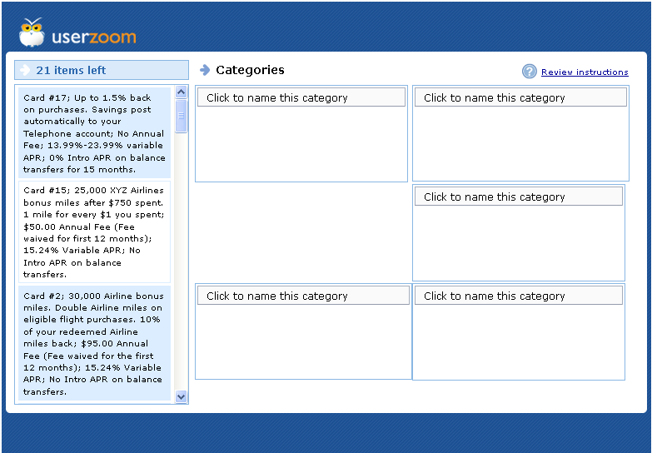

The following is a screen shot of the user being asked to provide a name and description for the categories they populated with card names.
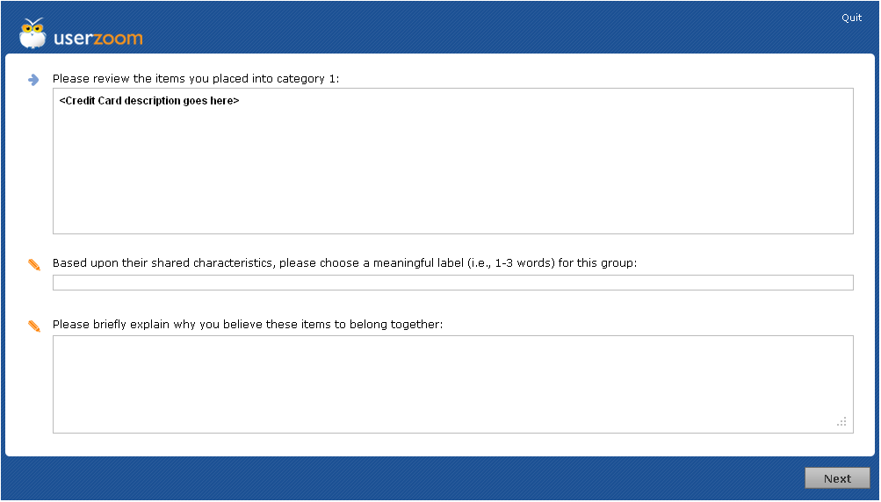

Final Questionnaire

The participants will be presented with the follow questions as presented below:
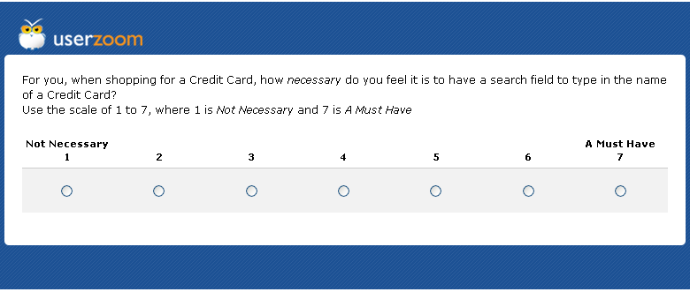
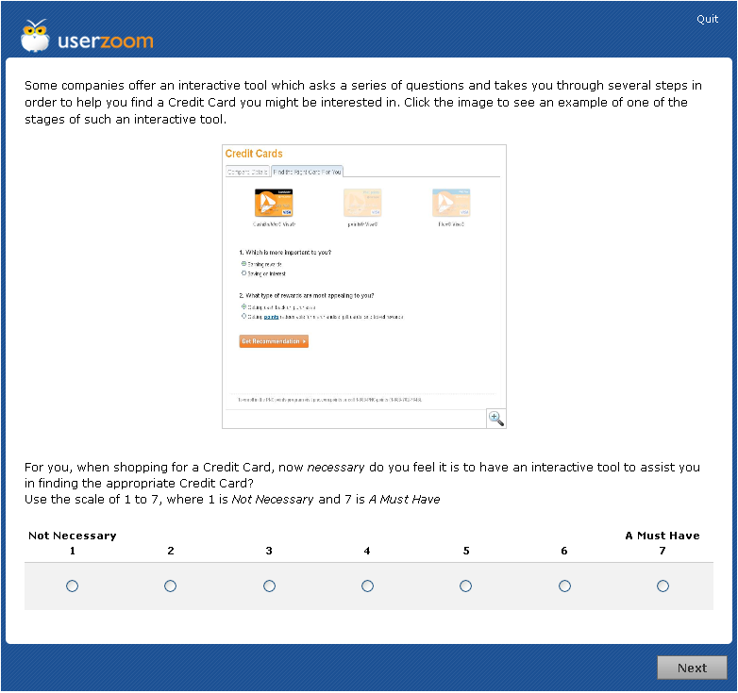
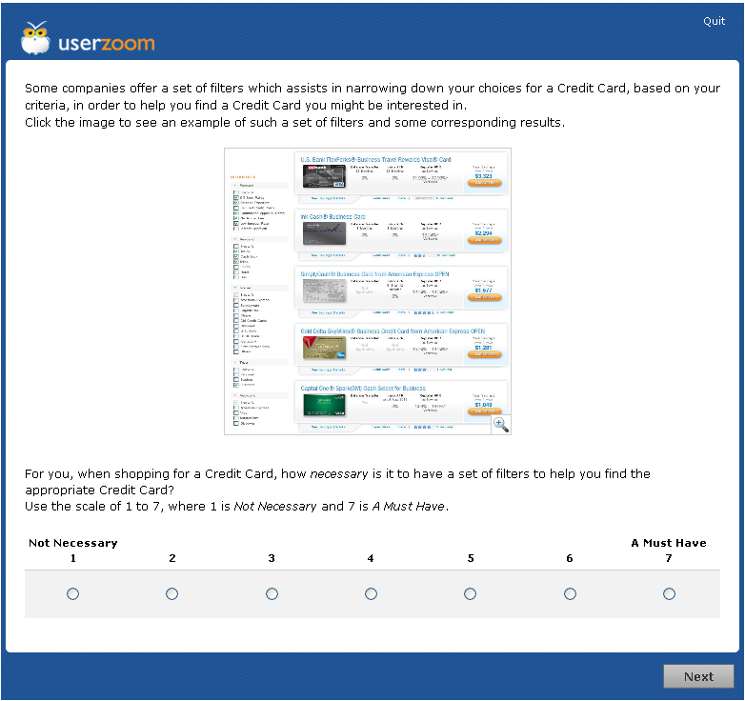
After this question, the participant will be presented with the following screen indicating that the study is completed:


