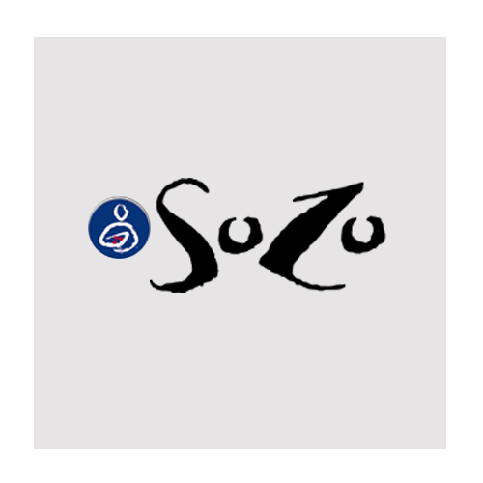
73% Positive Reaction
27% Negative Reaction

Descriptors:
Intriguing | 16% | Disinteresting | 2%
Exciting | 2% | Boring | 2%
Sophisticated |  | Common
Quality |  | Cheap | 2%
Strong | 4% | Weak
Youthful | 7% | Old Fashioned
Comfortable |  | Edgy | 12%
Trustworthy |  | Unreliable
Energetic | 9% | Lethargic
Unique | 16% | Common
Attractive | 7% | Ugly | 4%
Modern | 12% | Traditional | 2%

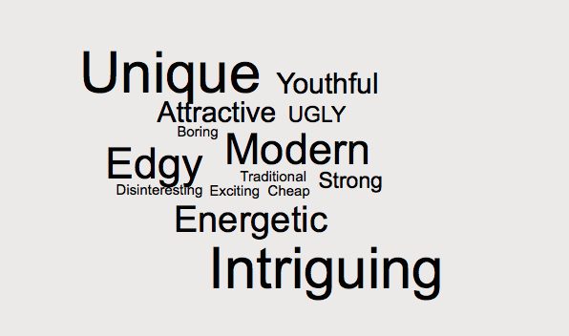
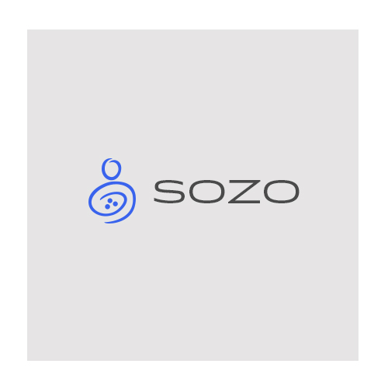
79% Positive Reaction
21% Negative Reaction

Descriptors:
Intriguing | 12% | Disinteresting | 4%
Exciting | 2% | Boring | 4%
Sophisticated | 10%
Quality | 6% | Cheap
Strong | 8% | Weak | 4%
Youthful | 6% | Old Fashioned
Comfortable | 2% | Edgy | 2%
Trustworthy | 4% | Unreliable
Energetic | 6% | Lethargic
Unique | 6% | Common
Attractive | 6% | Ugly
Modern | 13% | Traditional | 6%
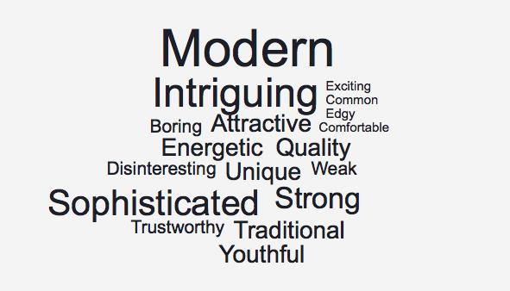


39% Positive Reaction
51% Negative Reaction
Descriptors:
Intriguing |  | Disinteresting | 9%
Exciting |  | Boring | 9%
Sophisticated | 7%
Quality | 2% | Cheap | 2%
Strong | 7% | Weak | 2%
Youthful |  | Old Fashioned | 7%
Comfortable | 7% | Edgy | 2%
Trustworthy |  | Unreliable
Energetic | 2% | Lethargic
Unique |  | Common | 18%
Attractive | 2% | Ugly | 2%
Modern | 11% | Traditional | 9%
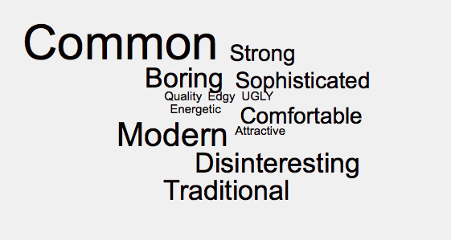
Paired Comparison Results*

59% Preference 12% Preference 29% Preference
209 Votes 42 Votes 102 Votes

Including the magnitude of “goodness” between the various comparisons (each magnitude of ‘goodness’ counted as a vote and all data was normalized to reduce to factors of 1,2, and 3) along with the frequency of choosing each logo option there was a total of 353 ‘votes’.

*This is a paired comparison test that tests preference of one item over the other and allows for a magnitude of ‘goodness’ of choices.

